MACHINE MASTER

Do the login

Go to setup and maintenance and click on machine master

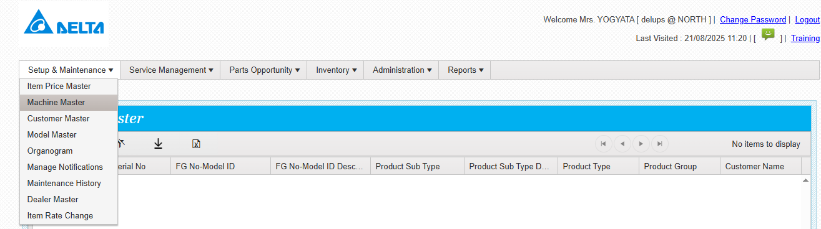

The below screen will appear

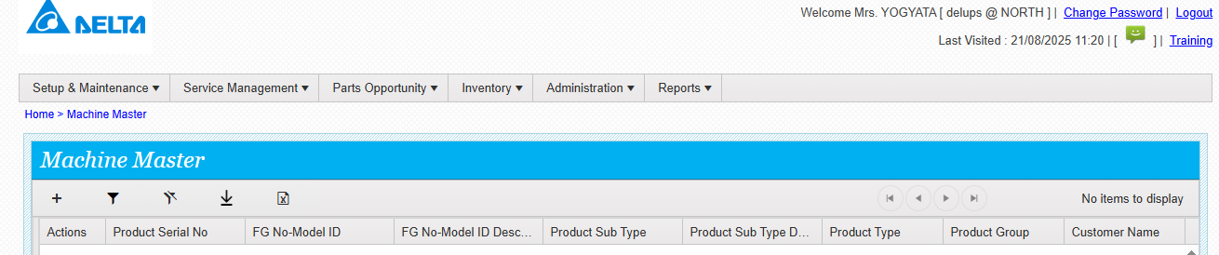

Click on plus to add new machine

And enter the standard info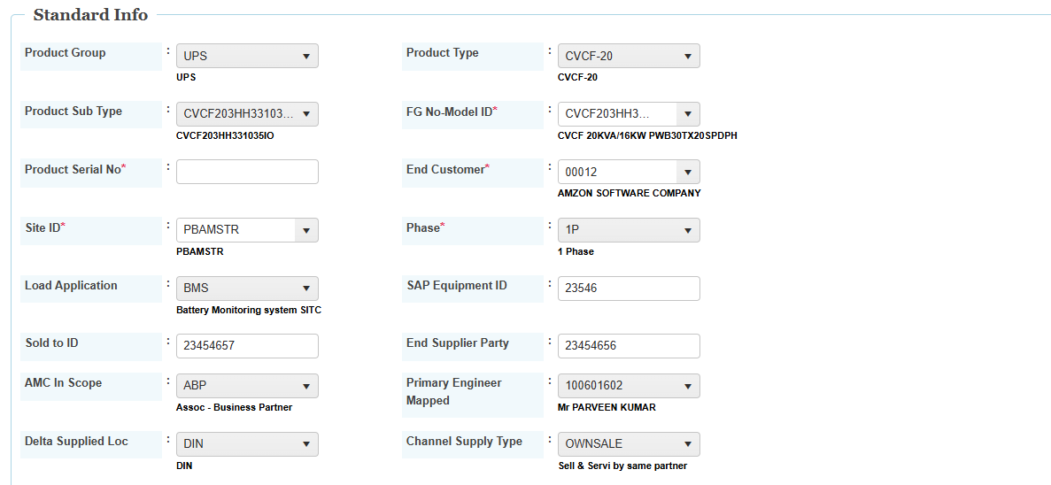

Enter the Billing information

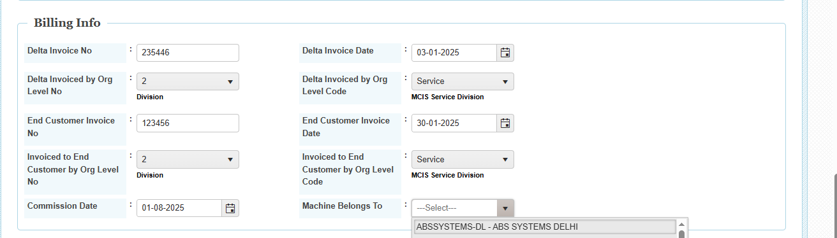

Enter the standard warranty template

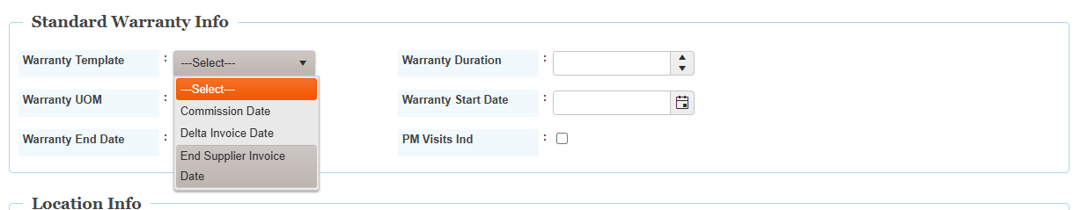

Once the warranty template is selected then system wil fetch the data

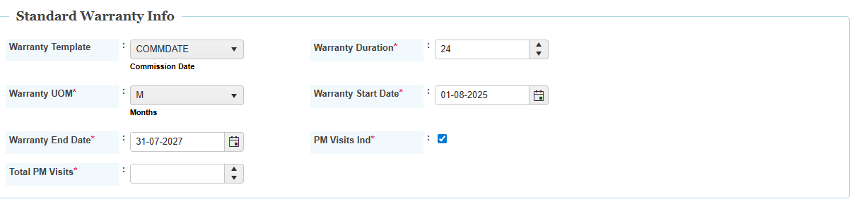

Warranty duration is editable ,PM visit indicator if yes then enter the total no of visits ,

Submit now, machine details saved successfully.

